***RIGHT MEAL RIGHT TIME REPORT***

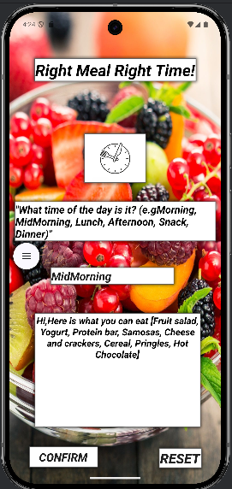

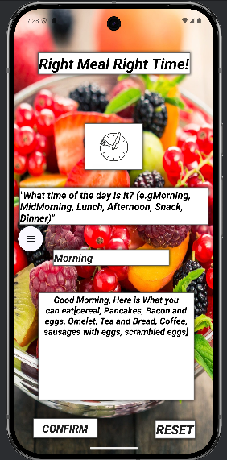

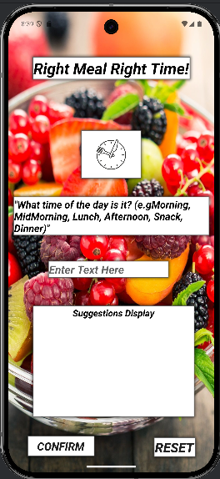

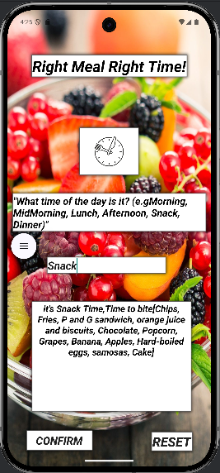

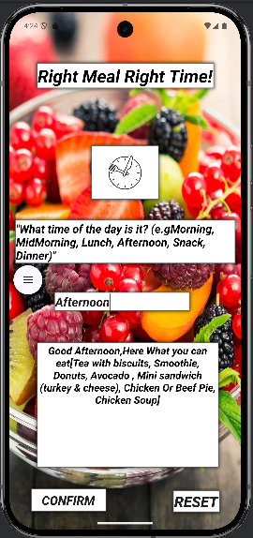

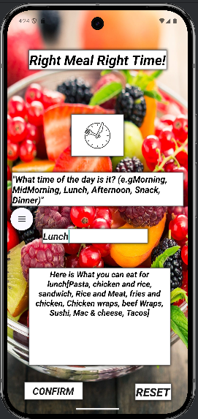

***CONCLUSIONS***

Right Meal Right Time functions perfectly as intended. When provided with the correct input format as recommended above, the app processes the data accurately, ensuring that the confirm and reset buttons work flawlessly. Additionally, error handling is implemented,effectively preventing invalid inputs from disrupting functionality.

***DOWNSIDE***

The only limitation is that the app is case-sensitive when recognizing the time of day—if the input does not match the expected format word for word as shown above (e.g., all uppercase or all lowercase), it will trigger the error handling message instead of displaying the appropriate output.

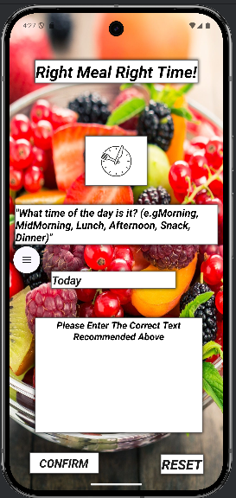

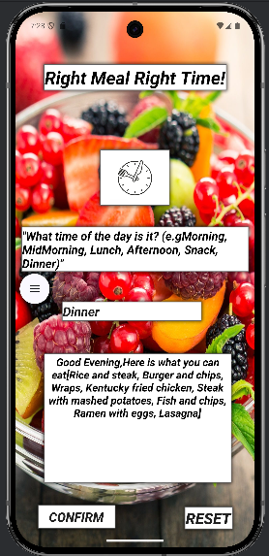

***DOWNSIDE***

